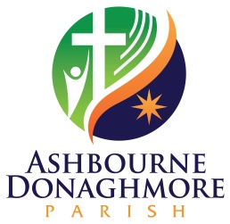

Confidential Declaration Form (Ref. S4.4)

Data Protection

This form will be held on file in accordance with the data protection policy of the Diocese of Meath. The data entered will be used only for the purposes indicated on the form. It may be accessed only by those with responsibility for managing files.

Legislation in both jurisdictions in Ireland has, at its core, the principle that the welfare of children must be the paramount consideration. The Diocese of Meath requires that everyone working or volunteering for the Church, who will come into contact with children or the personal details of children, abide by good practice by completing and signing this declaration.

Do you have any prosecutions pending, or have you ever been convicted of a criminal offence or been the subject of a caution or binding over order?
Yes No
If yes, please state below the nature and date(s) of the offence(s).
Date of offence
Nature of offence

Have you ever been the subject of disciplinary procedures or been asked to leave employment or voluntary activity due to inappropriate behaviour towards a child?
Yes No
If yes, please provide details including date(s)

Full name (print)
Any previous surname
Address

Date of birth ________________________ Place of birth _____________________________

What role/position are you currently applying for?

Declaration
I understand that if it is found that I have withheld information or included any false or misleading information above, I may be removed from my post, whether voluntary or paid, without notice. I understand that the information will be kept securely by the Diocese of Meath.

I declare that the information I have provided is accurate.

Signed ______________________________________ Date ___________________________

