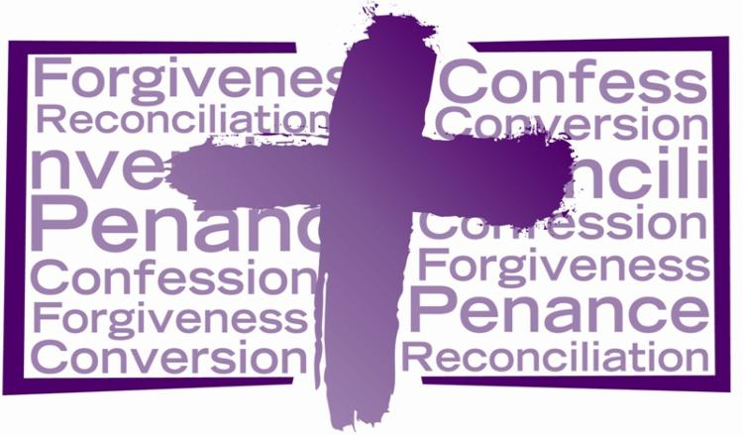

Examination of Conscience
First Commandment:
I am the Lord your God. You shall not have strange gods before Me.
- Have I loved God first and with all of my heart?
- Have I been faithful to my daily prayers?
- Have I given too much importance to any creature, activity, hobby, object or opinion?
- Do I strive to develop a close relationship with God through prayer and reading and encourage my children to do so?
- Do I place my trust in superstitions, good luck charms, Tarot/Angel Cards, fortune tellers, rather than God alone?
- Do I participate in practices that are contrary to God’s will: pagan practices, ouija boards, witchcraft etc.?
- Do I try to do the will of God or do I consult God in my decisions?

Second Commandment:
You shall not take the name of the Lord your God in vain.
- Have I sworn by God’s name falsely, rashly or in slight and trivial matters? Have I taken the name of Jesus or Christ in vain?
- Have I angered others so as to make them swear or blaspheme God?

Third Commandment:
Remember to keep holy the Sabbath day.
- Have I missed Mass on Sundays or Holy Days of obligation?
- Have I been deliberately late for Mass on Sundays or Holy Days of obligation or left early without good reason?
- Have I done or commanded unnecessary servile work on Sunday or Holy Days of Obligation?
- Have I received Holy Communion with love or rather with indifference?
- Do I listen and pay good attention at mass?

Fourth Commandment:
Honour your father and your mother.
- Have I been disobedient or disrespectful to my parents, or have I neglected or refused to help them in their needs or old age?
- Have I shown irreverence to others in positions of authority?
- Have I mistreated my spouse or my children?
- Have I given them bad example?

Fifth Commandment:
You shall not kill.
- Have I held on to hatred? Is there anyone I cannot forgive?
- Have I desired or hastened the death or bodily injury of anyone?
- Have I desired revenge?
- Have I caused division between others?
- Have I fought with anyone physically or verbally?
- Have I wished evil on anyone?
- Have I intended or attempted to injure or mistreat others?
- Is there anyone with whom I refuse to speak, or against whom I bear a grudge?
- Have I taken pleasure in anyone’s misfortunes?
- 10. Do I drink too much or too often or used illicit drugs?

Sixth and Ninth Commandments:
You shall not commit adultery. You shall not covet your neighbour’s wife.
- Have I committed adultery or fornication (premarital sex)?
- Have I practiced birth control (by pills, devices)?
- Have I sinned impurely by myself (masturbation)?
- Have I entertained or taken pleasure in impure thoughts?
- Have I done anything to provoke or occasion impure thoughts or desires in others deliberately or through carelessness or dress?
- Have I watched suggestive movies, TV programs, or Internet pornography or permitted my children to do so?
- Have I told indecent stories or used indecent language?
- Have I abused anyone for my own sexual gratification?

Seventh and Tenth Commandments:
You shall not steal. You shall not covet your neighbour’s goods.
- Have I stolen anything? What or how much?
- Have I been careless with other people’s money or goods?
- Have I cheated or others?
- Have I refused or neglected to pay any debts?
- Have I acquired anything known to be stolen?
- Have I gambled too often or excessively?
- Have I cheated my employer of an honest day’s work?
- Have I cheated my employees of their wages?
- Have I refused or neglected to help anyone in urgent need?
- Have I been jealous of what another has?
- Have I been mean with my possessions?
- Have I supported the poor or charitable organisations?

Eighth Commandment:
You shall not bear false witness against your neighbour.
- Do I exaggerate or tell lies?
- Have I rashly judged anyone?
- Have I engaged in gossip or injured the good name of another by revealing true but hidden faults?
- Have I disclosed another´s sins?
- Have I caused division, (i.e. reporting something unfavourable said of someone by another so as to create enmity between them)?
- Am I, without necessity, critical, negative or ever uncharitable in my talk?

