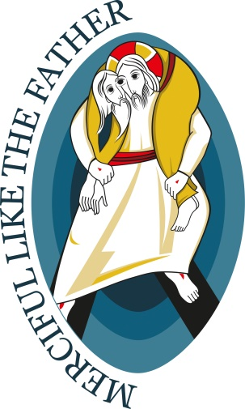

Year of Mercy – In Summary

Pope Francis on Saturday afternoon proceeded with the presentation of the official Bull of Indiction of the Extraordinary Jubilee of Mercy, set to begin on 8 December 2015. The bull is the fundamental document for the Holy Year that outlines the overall spirit and intentions for the Jubilee, as well as the spiritual fruits that are hoped for.
It was read by Fr Leonardo Sapienza, Regent of the Prefecture of the Pontifical Household, in a ceremony by the Holy Door of St Peter’s Basilica.
Pope Francis then moved into the basilica to preside Vespers for Divine Mercy Sunday.
The 28-page bull, titled “Misericordiae Vultus” or “The Face of Mercy” opens with the declaration, “Jesus is the face of the Father’s mercy. These words might well sum up the mystery of the Christian faith.”
In the document, Pope Francis says the Holy Year is “dedicated to living out in our daily lives the mercy” which God “constantly extends to all of us.” He explains the year will begin on 8 December to commemorate both the feast of the Immaculate Conception and the 50th anniversary of the closing of the Second Vatican Council, which called the Church to proclaim the Gospel to the world in new ways, bringing God’s mercy to everyone.
After the Holy Door of St Peter’s is open on December 8, the Holy Doors of the other papal basilicas will be opened in subsequent days. As well, as a sign of communion of the whole Church, the pope has requested that every diocese in the world open a similar “Door of Mercy” for the local celebrations of the Jubilee.
The document develops three main themes:
First, Pope Francis elaborates the theological understanding of God’s mercy, explaining the role of mercy in the life of people and of the Church, who are both the beneficiaries and the witnesses to God’s mercy in the world.
“The mercy of God is not an abstract idea, but a concrete reality through which he reveals his love as that of a father or a mother, moved to the very depths out of love for their child,” the Pope writes.
“Mercy is the very foundation of the Church’s life,” he continues. “The Church’s very credibility is seen in how she shows merciful and compassionate love.”
He recalls that the motto of the Holy Year is “Merciful like the Father.”
“Wherever the Church is present, the mercy of the Father must be evident,” he writes. “Wherever there are Christians, everyone should find an oasis of mercy.”
As a second theme, the Pope offers practical ways to live well the Holy Year: go on pilgrimage as an “impetus to conversion”; do not judge or condemn but forgive and give, avoiding gossip, envy and jealousy; have a heart open to the fringes of society and bring consolation, mercy and solidarity to people who live in precarious situations; take up the corporal and spiritual acts of mercy with joy; and observe the “24 Hours for the Lord” initiative, which encourages prayer and the sacrament of reconciliation, in every diocese during Lent.
He also addresses confessors, encouraging them to be “authentic signs of the Father’s mercy.” And, during Lent of the Holy Year, the Pope says he will send out “Missionaries of Mercy”–priests to whom he will grant “the authority to pardon even those sins reserved to the Holy See.” They will be “living signs of the Father’s readiness to welcome those in search of his pardon,” he writes.
As a third theme, the Pope issues particular calls for justice and conversion. He asks members of criminal organizations and those involved in corruption to change their lives and to embrace God’s mercy.
He also notes that both Judaism and Islam “consider mercy to be one of God’s most important attributes.” And he expresses “trust that this Jubilee… will foster an encounter” with these and other religions that will “open us to even more fervent dialogue” toward greater knowledge and understanding, “eliminate every form of closed-mindedness and disrespect and drive out every form of violence and discrimination.”
He also recalls the relationship between justice and mercy as “two dimensions of a single reality that…culminates in the fullness of love.”
“God does not deny justice,” he continues. “He rather envelopes it and surpasses it with an even greater event (mercy) in which we experience love as the foundation of true justice.”
The pope concludes the bull with an invocation to Mary, witness to God’s mercy and recalls saint who dedicated their lives to making God’s mercy known, namely the Polish St Faustina Kowalska.
After excerpts from the document were read on Saturday evening, Pope Francis gave a copy of the bull to the cardinal archpriests of each of the four papal basilicas in Rome, as well as to cardinals from the different continents, representing the Church throughout the world.
As with all Jubilees, a plenary indulgence is granted during the Holy Year of Mercy for those who fulfill all of the usual requirements.
The Holy Year will conclude on November 20, 2016, on the feast of Christ the King.

